**Title of the Paper (Arial 14 bold)**

**Author1, Author2*, Author3 (Arial 12 bold)**

1Complete Affiliation details

2Complete Affiliation details

3Complete Affiliation details

**ABSTRACT**

*Arial 11 Italic (not more than 250 words)*

***Keywords:*** *Arial 11 italic (not more than 5 keywords, each keyword should be separated by comma).*

1. **Introduction**

Line spacing 1.5 lines throughout the manuscript

Arial 12 Arial 12 Arial 12 Arial 12 Arial 12 Arial 12 Arial 12 [1] Arial 12 Arial 12 Arial 12 Arial 12 [2-4]. References in the body must be enclosed in squre brackets.

Arial 12 Arial 12 Arial 12 [5, 6] Arial 12 Arial 12 Arial 12 Arial 12 Arial 12 Arial 12 Arial 12

Arial 12 Arial 12 Arial 12 Arial 12 Arial 12 Arial 12 Arial 12 Arial 12 Arial 12 Arial 12 Arial 12 Arial 12 Arial 12 Arial 12 Arial 12 Arial 12 Arial 12 Arial 12 Arial 12 Arial 12 Arial 12 Arial 12 Arial 12 Arial 12 Arial 12 Arial 12 Arial 12 Arial 12 Arial 12 Arial 12.

1. Materials and methods
   1. *Materials*

Arial 12 Arial 12 Arial 12 Arial 12 Arial 12 Arial 12 Arial 12 Arial 12 Arial 12 Arial 12 Arial 12 Arial 12 Arial 12 Arial 12 Arial 12 Arial 12 Arial 12 Arial 12 Arial 12 Arial 12 Arial 12 Arial 12 Arial 12 Arial 12 Arial 12 Arial 12 Arial 12 Arial 12 Arial 12 Arial 12 Arial 12 Arial 12 Arial 12 Arial 12 Arial 12 Arial 12 Arial 12 Arial 12 Arial 12 Arial 12 (Table 1).

***Table 1.*** *(Must not be embedded in the body of the manuscript)*

* 1. *Methods*

Arial 12 Arial 12 Arial 12 Arial 12 Arial 12 Arial 12 Arial 12 Arial 12 Arial 12 Arial 12 Arial 12 Arial 12 Arial 12 Arial 12 Arial 12 Arial 12 Arial 12 Arial 12 Arial 12 Arial 12 Arial 12 Arial 12 Arial 12 Arial 12 Arial 12 Arial 12 Arial 12 Arial 12 Arial 12 Arial 12 Arial 12 Arial 12 Arial 12 Arial 12 (Table 2) Arial 12 Arial 12 Arial 12 Arial 12 Arial 12 Arial 12 (Fig. 1).

(Eq. 1) to determine the optimal arrangement of variables.

(1)

here, = number of runs, = ultimate tensile strength in the ith experiment (MPa).

***Table 2*** *(Must not be embedded in the body of the manuscript)*

***Fig. 1*** *(Must not be embedded in the body of the manuscript)*

* 1. *Characterizations*

Arial 12 Arial 12 Arial 12 Arial 12 Arial 12 Arial 12 Arial 12 Arial 12 Arial 12 Arial 12 Arial 12 Arial 12 Arial 12 Arial 12 Arial 12 Arial 12 Arial 12 Arial 12 Arial 12 Arial 12 Arial 12 Arial 12 Arial 12 Arial 12 Arial 12 Arial 12 Arial 12 Arial 12 Arial 12 Arial 12 Arial 12 Arial 12 Arial 12 Arial 12 Arial 12 Arial 12 Arial 12 Arial 12 Arial 12 Arial 12 (Fig. 2).

***Fig. 2*** *(Must not be embedded in the body of the manuscript)*

Arial 12 Arial 12 Arial 12 Arial 12 Arial 12 Arial 12 Arial 12 Arial 12 Arial 12 Arial 12

Arial 12 Arial 12 Arial 12 Arial 12 Arial 12 Arial 12 Arial 12 Arial 12 Arial 12 Arial 12 Arial 12 Arial 12 Arial 12 Arial 12 Arial 12 Arial 12 Arial 12 Arial 12 Arial 12 Arial 12 Arial 12 Arial 12 Arial 12 Arial 12 Arial 12 Arial 12 Arial 12 Arial 12 Arial 12 Arial 12.

1. Results and Discussion
   1. *Phase analysis and Morphology of MWCNT and SiO2 nanoparticles*

Arial 12 Arial 12 Arial 12 Arial 12 Arial 12 Arial 12 Arial 12 Arial 12 Arial 12 Arial 12 Arial 12 Arial 12 Arial 12 Arial 12 Arial 12 Arial 12 Arial 12 Arial 12 Arial 12 Arial 12 Arial 12 Arial 12 Arial 12 Arial 12 Arial 12 Arial 12 Arial 12 Arial 12 Arial 12 Arial 12 Arial 12 Arial 12 Arial 12 Arial 12 Arial 12 Arial 12 Arial 12 Arial 12 Arial 12 Arial 12.

The diameter of MWCNT was determined using the Debye-Scherer equation (Eq. 2).

(2)

where, d is the average diameter of crystallite, K is shape constant (0.9), λ is radiation wavelength (1.54 Å), is full width at half maxima, is Bragg’s angle of respective peaks. Using (Eq. 2), the crystallite size of MWCNT was found to be about 10 nm.

However, the XRD pattern of SiO2 (Fig. 3) peaks shows a typical nature of amorphous SiO2 with no clear peaks, only a broad hump. FESEM image (Fig. 4)

***Fig. 3*** *(Must not be embedded in the body of the manuscript)*

***Fig. 4*** *(Must not be embedded in the body of the manuscript)*

1. **Conclusions**

Arial 12 Arial 12 Arial 12 Arial 12 Arial 12 Arial 12 Arial 12 Arial 12 Arial 12 Arial 12 Arial 12 Arial 12 Arial 12 Arial 12 Arial 12 Arial 12 Arial 12 Arial 12 Arial 12 Arial 12 Arial 12 Arial 12 Arial 12 Arial 12 Arial 12 Arial 12 Arial 12 Arial 12 Arial 12 Arial 12 Arial 12 Arial 12 Arial 12 Arial 12 Arial 12 Arial 12 Arial 12 Arial 12 Arial 12 Arial 12.

**Acknowledgements** (if applicable)

*The authors are thankful to …………………………………. for providing support and facilities for the research work.*

**References**

1. Liu, N., Wang, H., Ma, B., Xu, B., Qu, L., Fang, D., & Yang, Y. (2022). Enhancing cryogenic mechanical properties of epoxy resins toughened by biscitraconimide resin. *Composites Science and Technology*, *220*, 109252.
2. Idumah, C. I., & Obele, C. M. (2021). Understanding interfacial influence on properties of polymer nanocomposites. *Surfaces and Interfaces*, *22*, 100879.
3. Zaghloul, M. M. Y., Zaghloul, M. M. Y., & Fuseini, M. (2023). Recent progress in Epoxy Nanocomposites: Corrosion, structural, flame retardancy and applications—A comprehensive review. Polymers for Advanced Technologies.
4. Parihar, S., & Gaur, B. (2023). Self healing approaches in polymeric materials-an overview. Journal of Polymer Research, 30(6), 1-21.
5. Wang, S., & Qiu, Y. (2022). Synthesis of SiO2 Nanoparticle Epoxy Resin Composite and Silicone-Containing Epoxy Resin for Coatings. *Applied Bionics and Biomechanics*, *2022*.
6. Bharadwaja, K., & Baburao, T. (2022). Epoxy/SiO2 nanocomposite mechanical properties and tribological performance. *Materials Today: Proceedings*, *62*, 1712-1716.

**Table Captions**

*Table 1. Typical properties of ………………...*

*Table 2. Variables or parameters and their levels used for the optimization.*

*Table 3. L5 orthogonal array showing value of Strength and associated S/N ration.*

**Figure Captions**

*Figure 1. Schematic process of a chemical reaction.*

*Figure 2. Schematic representation of a cake consisting different ingradients.*

*Figure 3. XRD pattern of (a) MWCNT and b) SiO2 nanoparticles.*

**Tables**

*Table 1 (No Caption here)*

|  |  |  |  |  |
| --- | --- | --- | --- | --- |
| Material | Viscosity at 25  (mPas) | Density at 25  (g/cm3) | Flash Point  ( | Storage Life  (years) |
|  |  |  |  |  |
|  |  |  |  |  |

*Table 2 (No Caption here)*

|  |  |  |  |
| --- | --- | --- | --- |
| Parameter  level | MWCNT  (wt%) | SiO2  (wt%) | Cycle |
| 1 |  |  | (C1) |
| 2 |  |  | (C2) |
| 3 |  |  | (C3) |
| 4 |  |  | (C4) |
| 5 |  |  | (C5) |

*Table 3 (No Caption here)*

|  |  |  |  |  |  |  |  |  |
| --- | --- | --- | --- | --- | --- | --- | --- | --- |
| Sample No | wt% CNT | wt% SiO2 | Cycle | Strength | S/N ratio | PTS (RA) | % error | Rank |
|  |  |  |  |  |  |  |  |  |
|  |  |  |  |  |  |  |  |  |
|  |  |  |  |  |  |  |  |  |
|  |  |  |  |  |  |  |  |  |
|  |  |  |  |  |  |  |  |  |
|  |  |  |  |  |  |  |  |  |
|  |  |  |  |  |  |  |  |  |
|  |  |  |  |  |  |  |  |  |
|  |  |  |  |  |  |  |  |  |
|  |  |  |  |  |  |  |  |  |
|  |  |  |  |  |  |  |  |  |
|  |  |  |  |  |  |  |  |  |
|  |  |  |  |  |  |  |  |  |
|  |  |  |  |  |  |  |  |  |
|  |  |  |  |  |  |  |  |  |
|  |  |  |  |  |  |  |  |  |
|  |  |  |  |  |  |  |  |  |
|  |  |  |  |  |  |  |  |  |
|  |  |  |  |  |  |  |  |  |
|  |  |  |  |  |  |  |  |  |
|  |  |  |  |  |  |  |  |  |
|  |  |  |  |  |  |  |  |  |
|  |  |  |  |  |  |  |  |  |
|  |  |  |  |  |  |  |  |  |
|  |  |  |  |  |  |  |  |  |

**Figures**

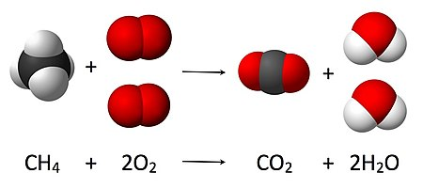

*Fig. 1 (No Caption here)*

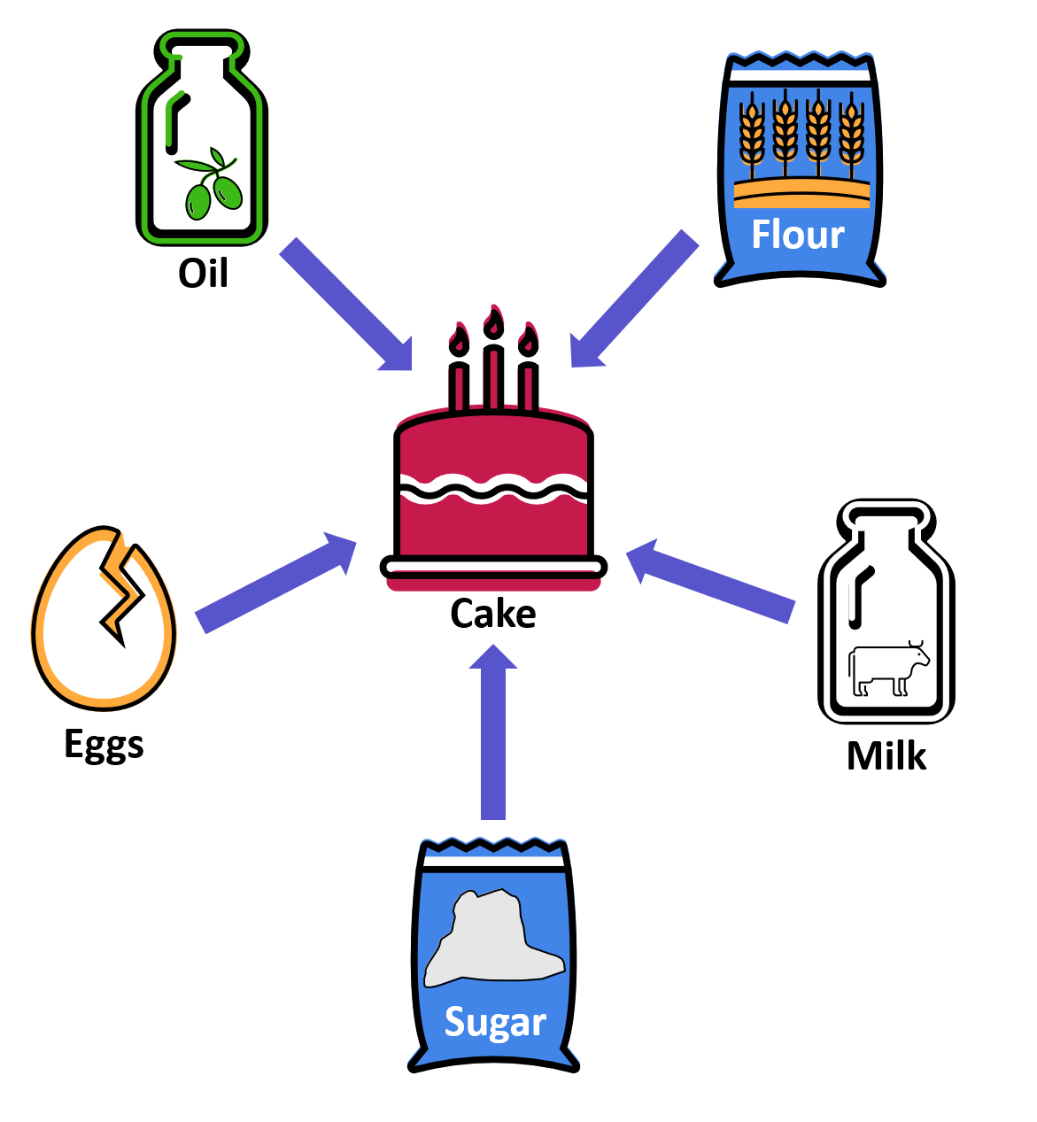

*Fig. 2 (No Caption here)*

C:\Users\avani\OneDrive\Desktop\figure3.tif

*Fig. 3 (No Caption here)*

**

*Fig. 4 (No Caption here)*